Project Development Phase
Data Visual

Date | 26 February 2026
Team ID
Project Name | An Exploration of Electricity Consumption Patterns
Maximum Marks | 3 Marks

PREPROCESSING STEPS

1. Data Import and Initial Inspection
The dataset containing electricity consumption details was imported into Tableau Public. The dataset consisted of 16,599 records and 6 attributes:
- States
- Regions
- Latitude
- Longitude
- Dates
- Usage
An initial inspection was performed to understand the structure, data types, and completeness of the dataset.

2. Handling Missing Values
The dataset was examined for null or missing values across all columns.
Observation:
No missing values were found in any attribute.
Since the dataset was complete, no imputation or deletion was required for missing values.

3. Removal of Duplicate Records
These duplicates were removed to ensure:
- Accurate aggregation
- No inflation of electricity consumption values
- Reliable analytical results
Removing duplicate records improved data integrity and prevented misleading insights.

5. Data Classification (Dimension & Measure Separation)
Fields were categorized appropriately:

Dimensions:
- States
- Regions
- Dates

Measures:
- Usage
- Latitude
- Longitude
This classification enabled proper aggregation and visualization in Tableau.

6. Time-Based Feature Extraction
To analyze electricity consumption trends over time, the following were derived from the Date field:
- Year
- Month
This allowed:
- Comparison between 2019 and 2020
- Monthly consumption trend analysis
- Identification of peak and low usage periods

8. Geographical Data Utilization
Latitude and Longitude fields were used to:
- Create geographical maps
- Visualize state-wise electricity consumption spatially
This enhanced visual interpretability of regional patterns.

9. Filtering and Sorting
Filters were applied to:
- Compare consumption between 2019 and 2020
- Identify highest and lowest consuming states
BUSINESS QUESTIONS ADDRESSED
The following business questions were formulated to guide the analysis and visualization of electricity consumption data for the years 2019 and 2020:

1. Year-wise Consumption Analysis (2019 vs 2020)
- How did electricity consumption change between 2019 and 2020?
- Was there a significant increase or decrease in overall consumption in 2020 compared to 2019?
- Which months exhibited the highest variation in electricity usage between the two years?

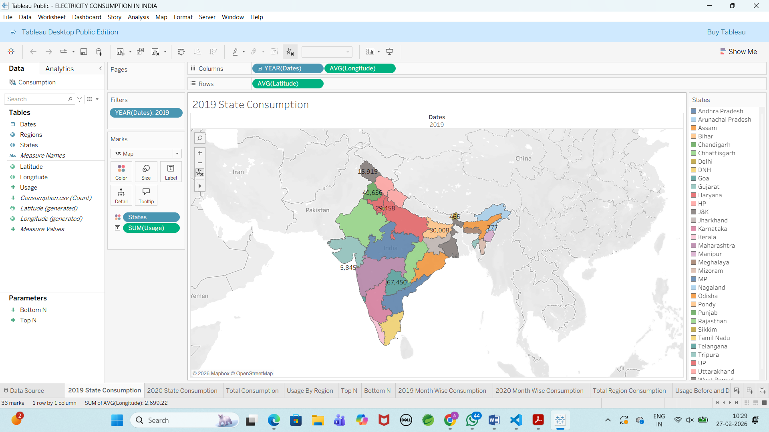

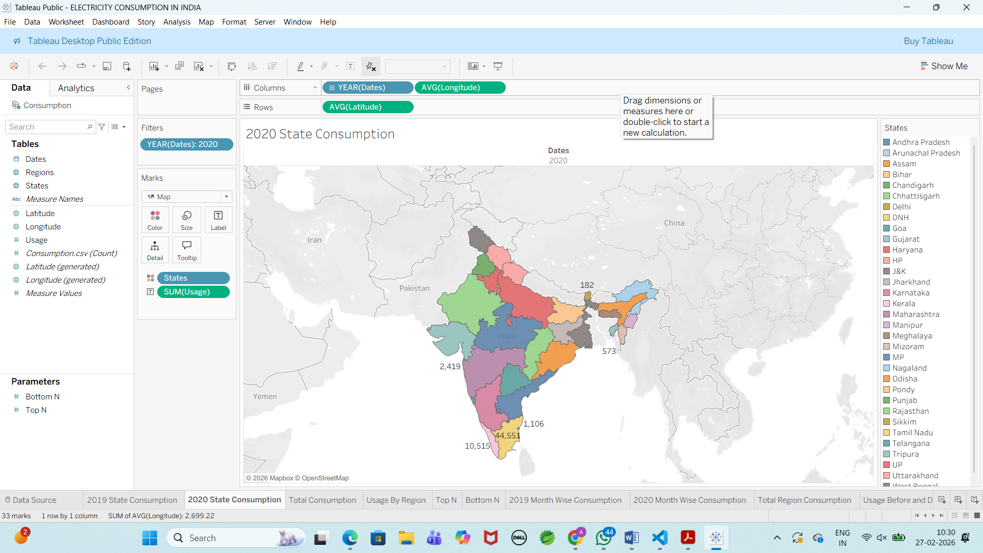

2. Total Electricity Consumption
- What is the total electricity consumption across India during the study period?
- What is the overall trend in national electricity demand?
- How does each year contribute to the total consumption?

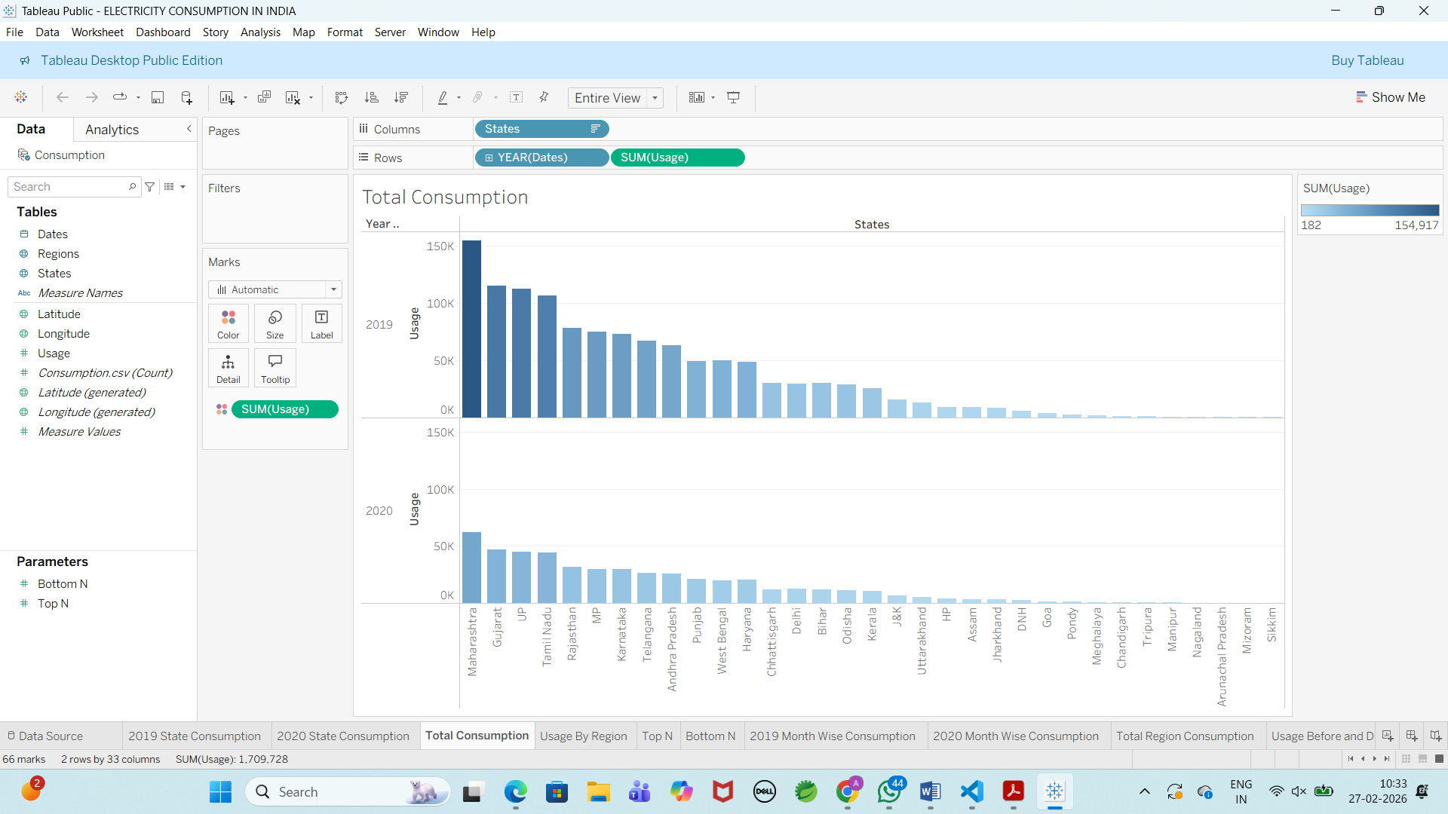

3. Regional Electricity Usage
- Which region has the highest electricity consumption?
- Which region records the lowest electricity consumption?
- How does electricity demand vary across different regions of India?
- Are certain regions more energy-intensive due to economic or industrial activities?

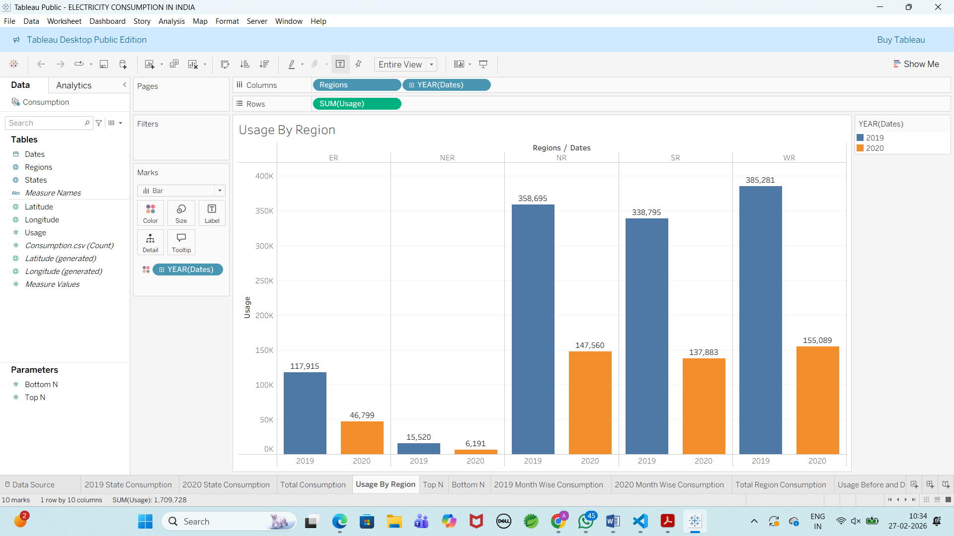

4. Top N and Bottom N States
- Which states are the highest consumers of electricity?
- Which states record the lowest electricity consumption?
- What factors might contribute to high or low electricity demand in specific states?
- How can policymakers use this information for infrastructure planning and energy distribution?

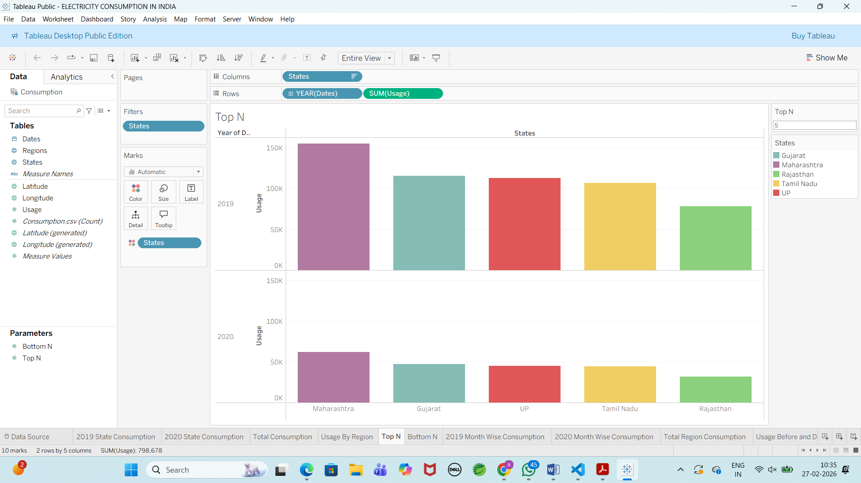

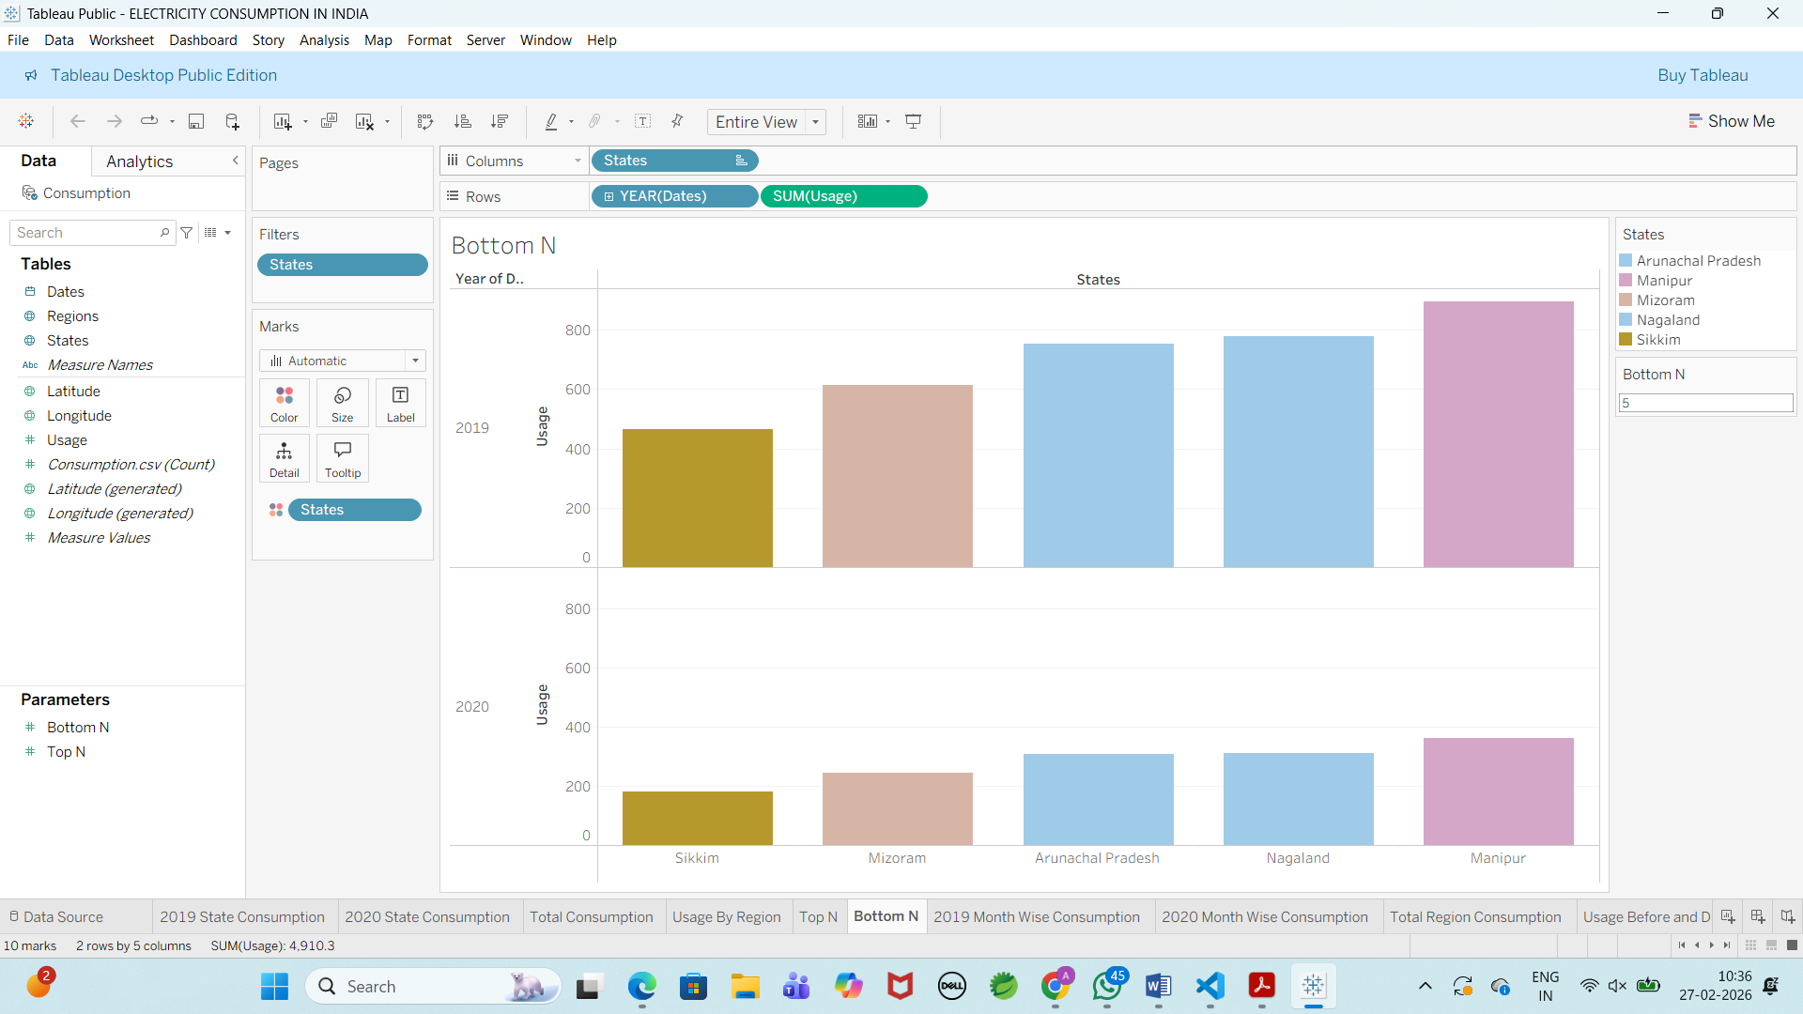

5. Month-wise Electricity Consumption for 2019 and 2020
Business Questions:
- How does monthly electricity consumption vary within each year?
- Are there seasonal patterns in electricity usage?
- How does monthly consumption in 2020 compare with the corresponding months in 2019?
- Which months experienced the highest and lowest electricity demand?
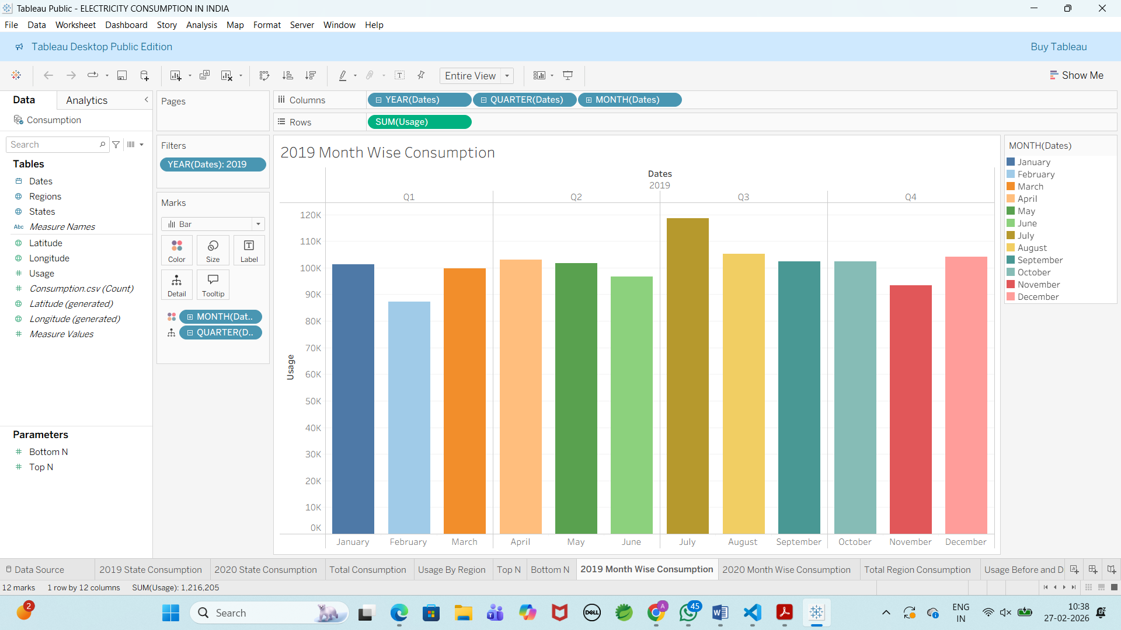

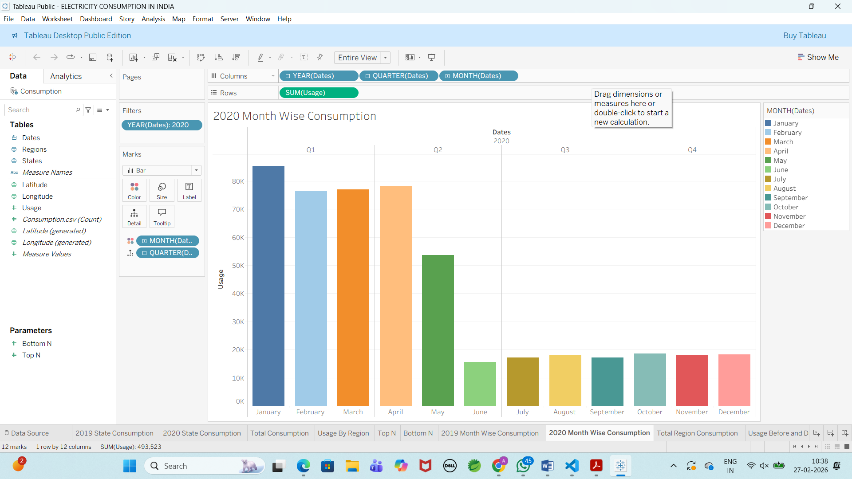

6. Total Electricity Consumption by Region
Business Questions:
- Which region has the highest overall electricity consumption?
- Which region records the lowest consumption?
- How does electricity usage differ across various regions of India?
- Are certain regions consistently high-demand zones?

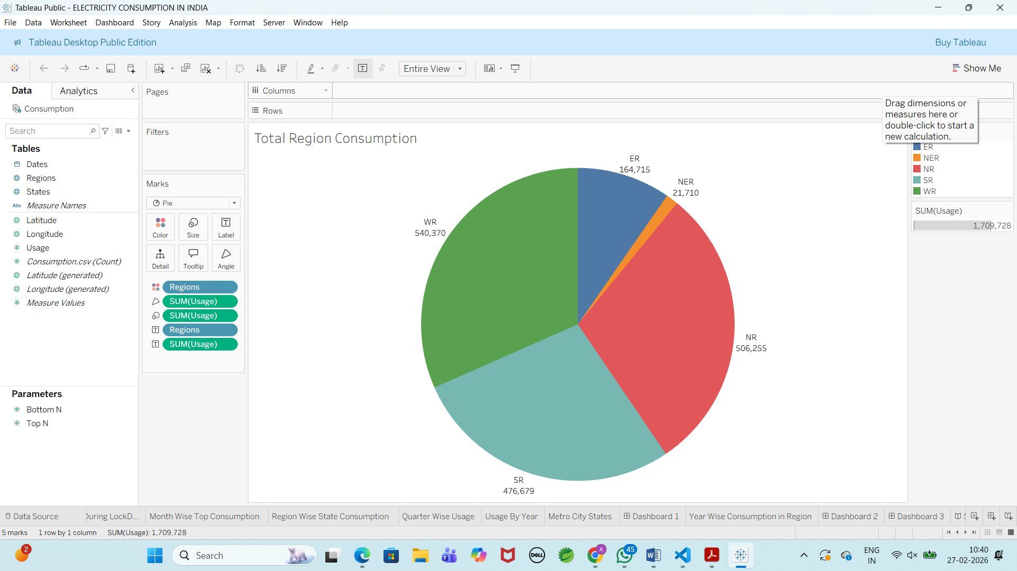

7. Electricity Usage Before and After Lockdown
Business Questions:
- Was there a significant change in electricity consumption after the implementation of the COVID-19 lockdown in 2020?
- How did consumption levels before lockdown compare to post-lockdown months?
- Which regions or states experienced the most noticeable decline or recovery?
- What impact did reduced industrial and commercial activity have on electricity demand?

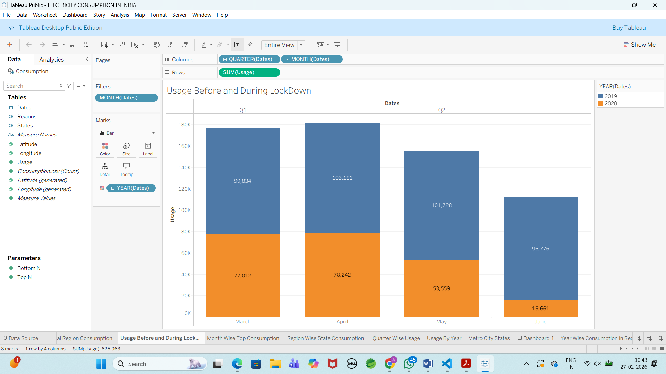

8. Region-wise Electricity Usage
Business Questions:
- Which region records the highest electricity consumption?
- Which region has the lowest electricity usage?
- How does electricity demand vary across different regions of India?
- Are certain regions consistently high-demand areas over time?

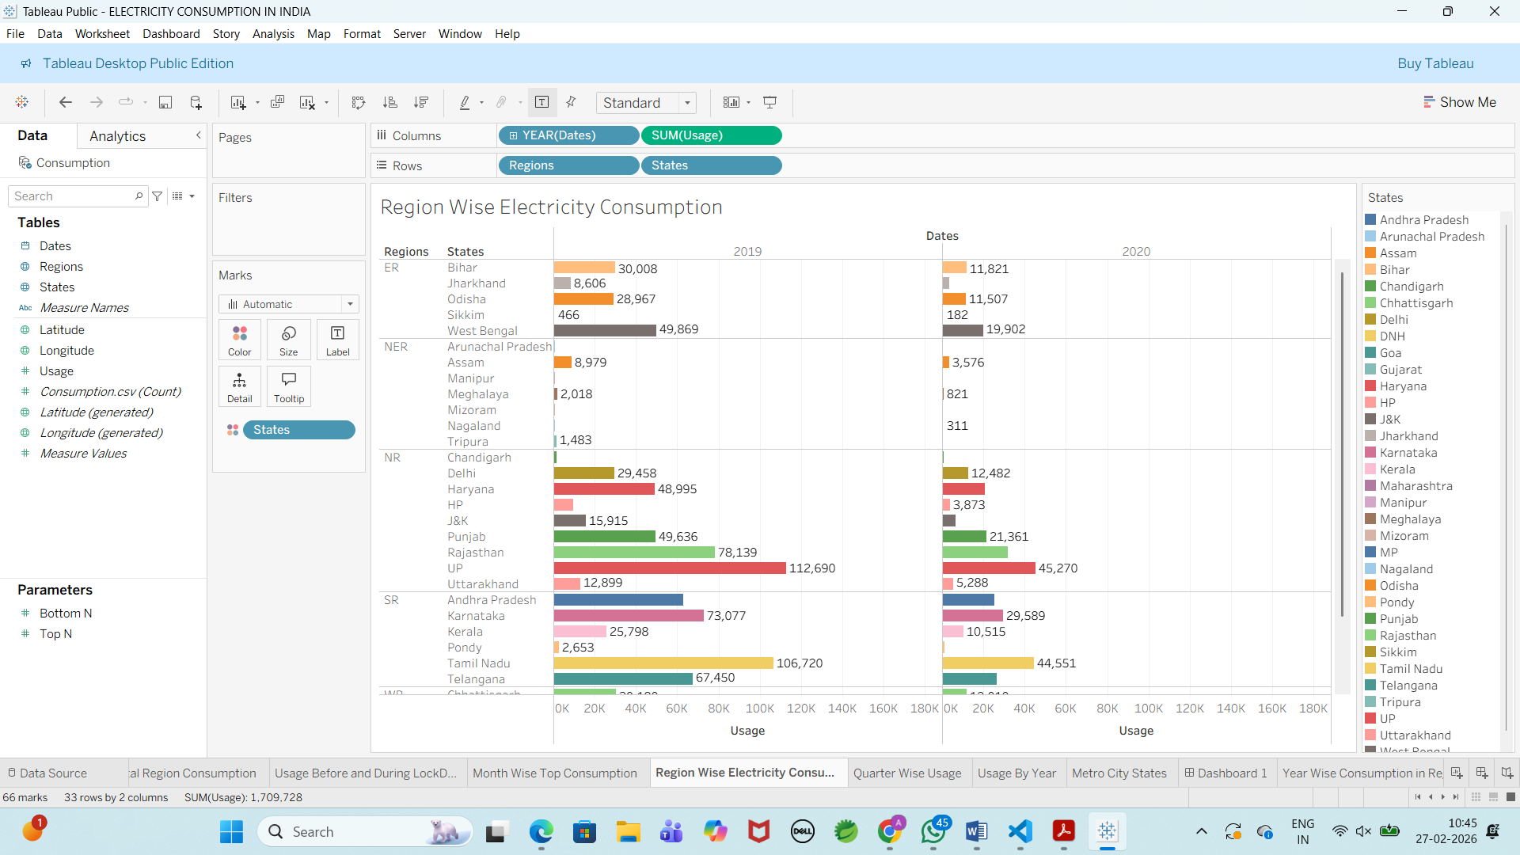

9. State-wise Electricity Usage
Business Questions:
- Which states are the highest consumers of electricity?
- Which states record the lowest electricity consumption?
- How does electricity demand differ across individual states?
- Is state-level consumption influenced by population size or industrial development?

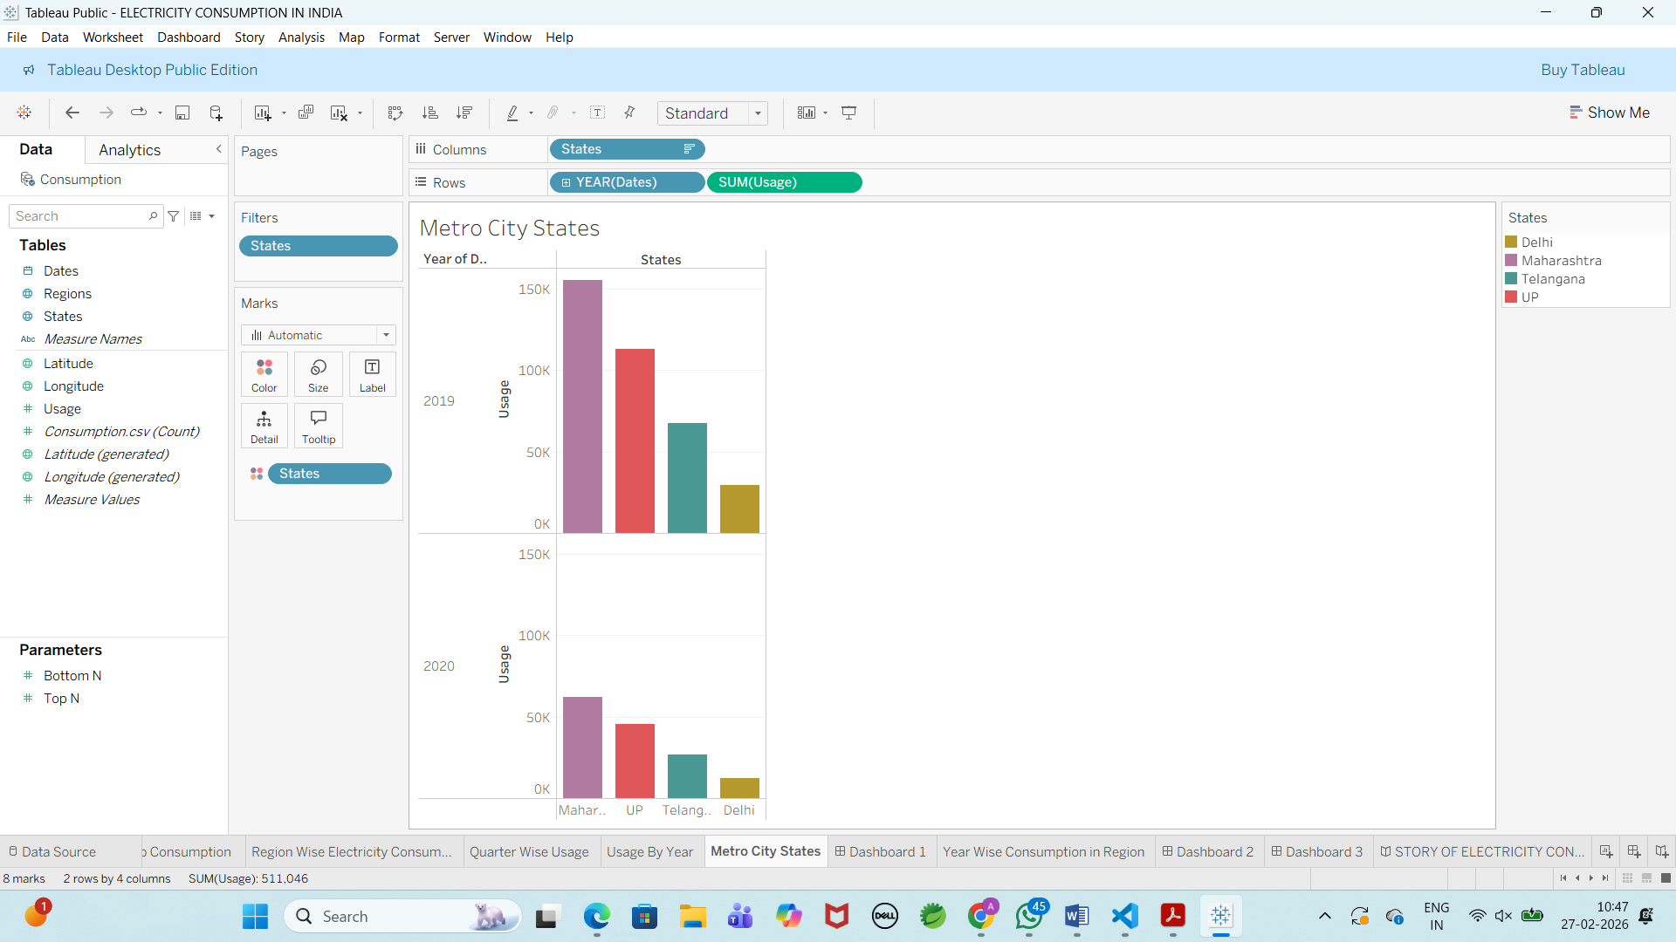

10. Quarter-wise Electricity Usage
Business Questions:
- How does electricity consumption vary across different quarters of the year?
- Are there seasonal patterns influencing quarterly demand?
- Which quarter consistently shows peak electricity usage?
- Is there any significant variation between quarters in different years?

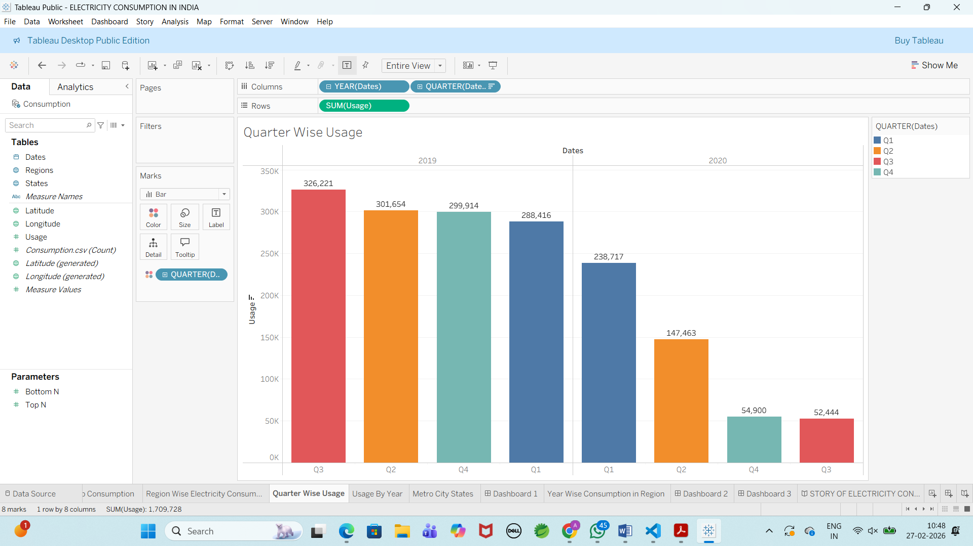

11. Year-wise Electricity Usage
Business Questions:
- What is the total electricity consumption for each year?
- Is there an overall increasing or decreasing trend over time?
- How does one year’s performance compare to another?
- Are there significant variations that indicate external influences?

